PROJECT REPORT ON MY PROJECT

1)INTRODUCTION

2)PROBLEM STATEMENT

3) REQUIREMENTS

4)ALGORITHM

5)FLOWCHART

6) CODE

7) RESULT

8) REFERNCE

PROJECT REPORT :

PROJECT TITLE : E-MAIL SPAM DETECTION USING MACHINE LEARNING
BY : MANALI SONI
REGISTRATION NUMBER : 25BCE10898
SLOT : B21 +E14+ E22
PROFESSOR : DR MK JAYANTHI MAM
SUBJECT : FUNDAMENTALS IN AIML

- INTRODUCTION :
My project is based on E-mail spam detection using machine learning. It is a system that helps in identifying whether the mail is spam or not. With machine learning, the system can learn from data this helps in keeping inboxes safe and secure.

- PROBLEM STATEMENT :
The cases of spammers are increasing day by day many emails cone like of advertisement ,fake offers, gift offers. We all need a system that can detect automatically whether the mail is spam or not.

- REQUIREMENTS :
    - Software requirements
- Python language
- Visual studio code , Jupyter notebook
- Libraries like: panda, numPy, Scikit-learn

- Hardware requirements
          - Basic computer knowledge
          - Minimum 4GB RAM
          - High internet connectivity

- Dataset requirements
- Collections of emails.
- The email should contain both spam as well as not spam.

- ALGORITHM :
- Start
- Collect different type so datasets.
- Convert text to lowercase ,remove numbers , stop words and special characters.
- Divide data into training and testing .
- Train the model.
- Predict the result and accuracy .
- Stop

- FLOWCHART :
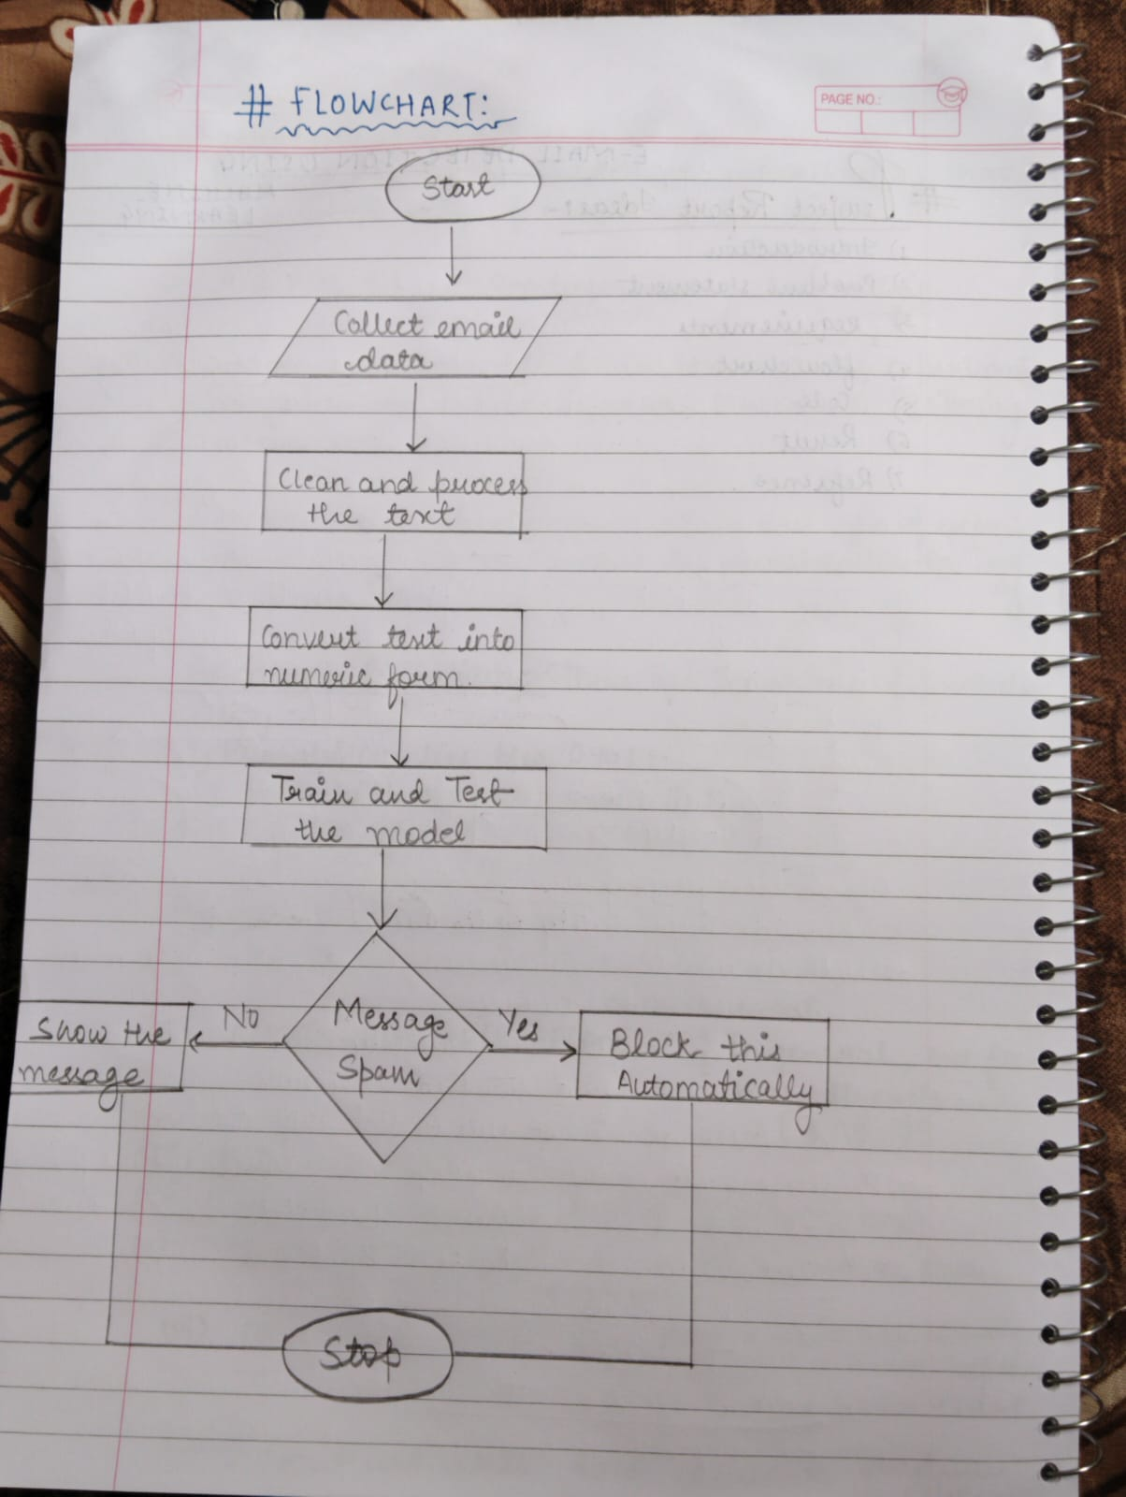

- CODE :
!pip install pandas scikit-learn
import pandas as pd
from sklearn.model_selection import train_test_split
from sklearn.feature_extraction.text import CountVectorizer
from sklearn.naive_bayes import MultinomialNB
from sklearn.metrics import accuracy_score

# Sample dataset
data = {
'email': [
'Win money now!!!',
'Hello friend how are you',
'Claim your free prize',
'Meeting at 10 am',
'Get rich quick scheme',
'Let us discuss project'
],
'label': [1, 0, 1, 0, 1, 0]
}

df = pd.DataFrame(data)

# Train-test split
X_train, X_test, y_train, y_test = train_test_split(df['email'], df['label'], test_size=0.3)

# Vectorization
vectorizer = CountVectorizer()
X_train_vec = vectorizer.fit_transform(X_train)
X_test_vec = vectorizer.transform(X_test)

# Model
model = MultinomialNB()
model.fit(X_train_vec, y_train)

# Prediction
y_pred = model.predict(X_test_vec)
print("Accuracy:", accuracy_score(y_test, y_pred))

# Custom test
test_email = ["You won a free gift!"]
test_vec = vectorizer.transform(test_email)
if model.predict(test_vec)[0] == 1:
print("Spam Email")
else:
print("Not Spam Email")

- RESULT : 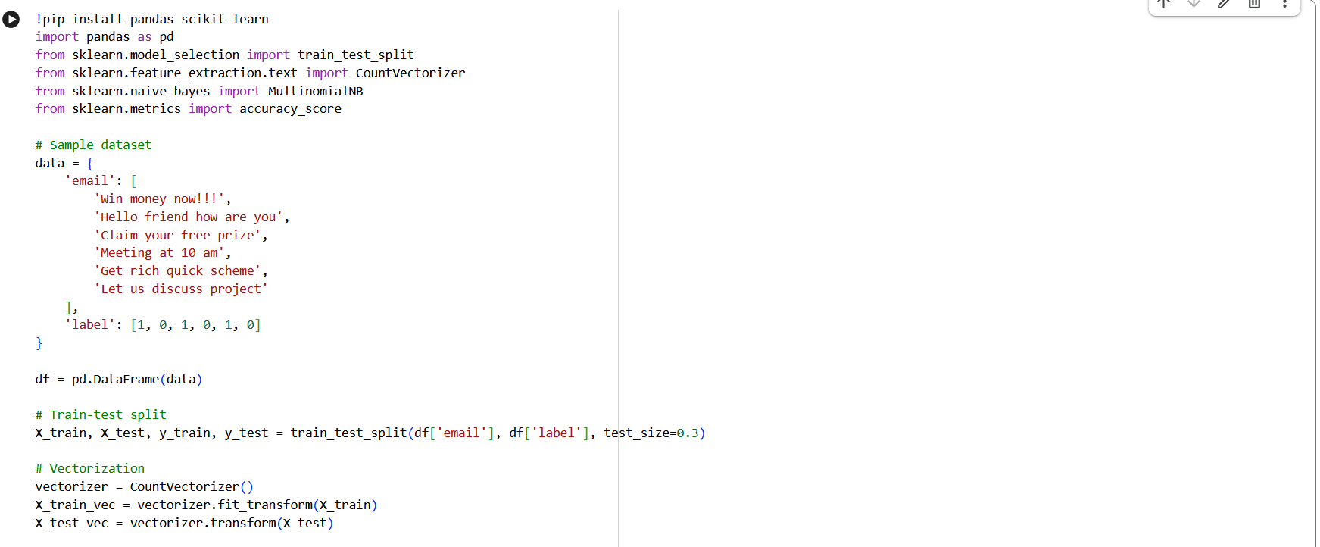
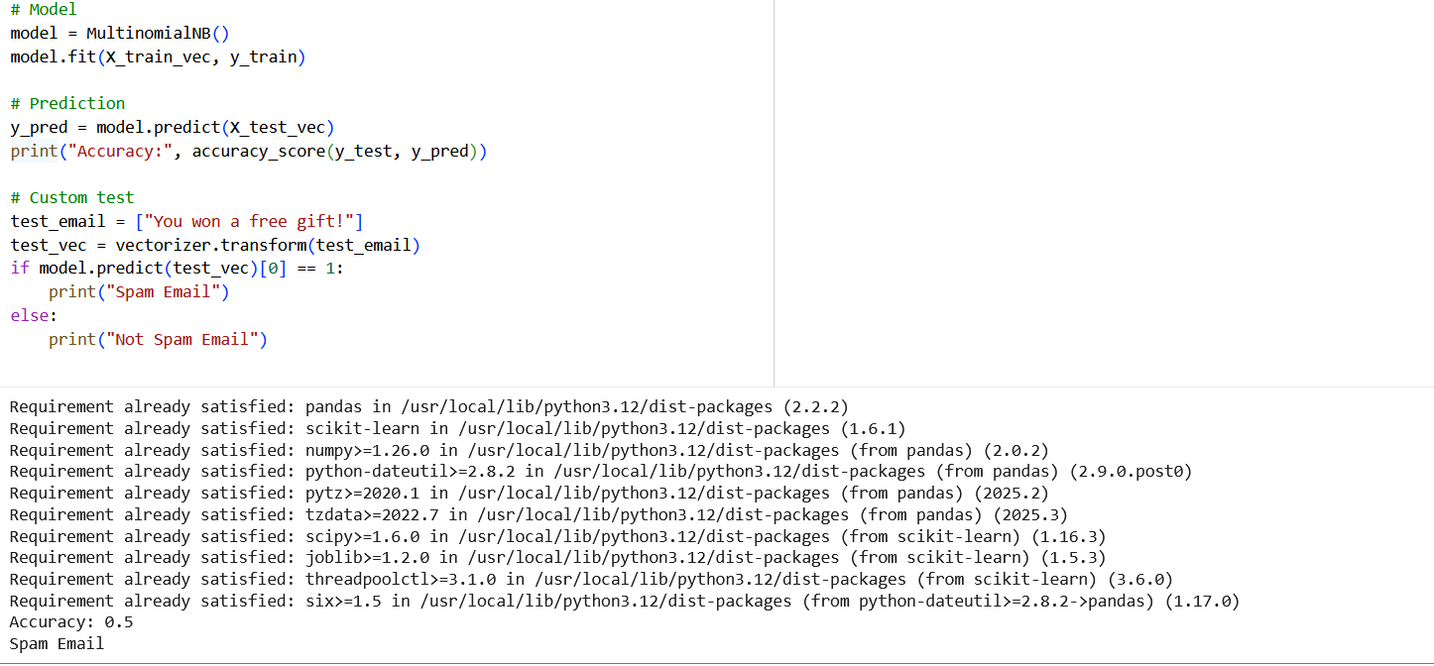
From the result we are getting to know the accuracy and prediction of our model whether our model is predicting correct or not .

- REFERENCE :
These links may help you to better understanding of the project idea and techniques used :
- Spam detection in machine learning : https://bit.ly/3nwiKtA
- Naive-bayes algorithm : https://bit.ly/3zc9SLH
- Model evaluation : https://bit.ly/3B12VOO
- Also used fundamentals in AIML (VITyarthi platform ).

